

# Amal Jyothi College of Engineering Kanjirappally, Kerala

**ANALYSIS OF WEATHER USING WEKA INTEGRATED MCA SEMINAR REPORT**

*Submitted in the partial fulfillment of the requirements for the*

*Award of the Degree in*

Integrated Master of Computer Applications By

# ALFIYA ABDUL SALAM

Reg No: AJC16MCA-I12

*Under The Guidance Of*

# Ms. ANKITHA PHILIP

**January 2021 DEPARTMENT OF COMPUTER**

**APPLICATIONS AMAL JYOTHI COLLEGE OF ENGINEERING KANJIRAPPALLY**



**CERTIFICATE**

*This is to certify that the seminar report*, “**ANALYSIS OF WEATHER USING WEKA ”** *is the bonafide work of* **ALFIYA ABDUL SALAM (Reg.No:AJC16MCA-I12)** *in partial fulfillment of the requirements for the award of the Degree of Integrated Master of Computer Applications under APJ Abdul Kalam Technological University during the year 2020- 21.*

# Ms. ANKITHA PHILIP Fr.Rubin Thottupuram Internal Guide Coordinator

**Fr. Rubin Thottupuram**

**Head of the Department**

# ACKNOWLEDGEMENT

First and foremost, I thank God almighty for his eternal love and protection throughout the seminar. I take this opportunity to express my gratitude to all who helped me in completing this seminar successfully. It has been said that gratitude is the memory of the heart. I wish to express my sincere gratitude to our manager **Rev. Fr. Dr. Mathew Paikatt** and Principal **Dr. Z V Lakaparampil** for providing good faculty for guidance.

I owe a great depth of gratitude towards our Head of the Department Fr. Rubin Thottupuram for helping us. I extend my whole hearted thanks to the seminar coordinators Fr. Rubin Thottupuram and Ms. Sona Maria Sebastian for their valuable suggestions and for overwhelming concern and guidance from the beginning to the end of the seminar. I would also like to express sincere gratitude to my guide, Ms.Ankitha philip for her inspiration and helping hand.

I thank our beloved teachers for their cooperation and suggestions that helped me throughout the seminar. I express my thanks to all my friends and classmates for their interest, dedication, and encouragement shown towards the seminar. I convey my hearty thanks to my family for the moral support, suggestions, and encouragement to make this venture a success.

# ABSTRACT

Weather is the single most events that affect the human life in every dimension.prediction of weather phenomena is of major interest for human society to avoid or minimize the destruction of weather hazards.Classification technique is a powerful way to classify the attributes of the dataset into different classes. Here we analysis data with j48 algorithm .its used to generate decision tree. Weather prediction is complex due to noise and missing values dataset

Then we compare the efficiencies of these classification algorithms. The tool we use for this approach is WEKA (Waikato Environment for Knowledge Analysis) a collection of open source machine learning algorithms

It’s a content field with a general goal of predicting outcomes and uncovering relationships. Some of the data mining techniques are Classification, Clustering and Rule MiningMost of the cluster algorithms area unit ascendable to large dataset. Weather is random entityForecasting is the technology to predict the atmosphere at given location and a given time taking into consideration various factors such as humidity, temperature, wind and outlook.

# CONTENTS

1. INTRODUCTION 1
   1. DATA MINING
   2. HISTORY OF DATA MINING
   3. WEKA DATA MINING TOOL
2. ANALYSIS OF WEATHER USING DECISION TREE ALGORITHM 12
   1. INTRODUCTION TO DECISION TREE ALGORITHM(J48 ALGORITHM)
   2. STEPS
   3. FEATURES
   4. LIMITATIONS
3. WORKING OF DECISION TREE ALGORITHM IN WEKA TOOL 16
4. NEW PROBLEM CONCEPT
5. CONCLUSION 31
6. REFERENCES 32

# INTRODUCTION

* 1. **Waikato Environment for Knowledge Analysis (WEKA)**

**Data mining** is a process of discovering patterns in large [data sets](https://en.wikipedia.org/wiki/Data_set) involving methods at the intersection of [machine learning](https://en.wikipedia.org/wiki/Machine_learning), [statistics](https://en.wikipedia.org/wiki/Statistics), and [database](https://en.wikipedia.org/wiki/Database_system) [systems](https://en.wikipedia.org/wiki/Database_system). Data mining is the analysis step of the "knowledge discovery in databases" process, or KDD. Data mining includes the utilization of refined data analysis tools to find previously unknown, valid patterns and relationships in huge data sets. Thus, data mining incorporates analysis and prediction. In recent data mining projects, various major data mining techniques have been developed and used, including association, classification, clustering, prediction, sequential patterns, and regression. **Data Mining tools** have the objective of discovering patterns/trends/groupings among large sets of data and transforming data into more refined information. It is a framework that allows you to perform different types of data mining analysis. We can perform various algorithms such as clustering or classification on your data set and visualize the results itself.

**WEKA** is a data mining tool developed by the University of Waikato in New Zealand that implements data mining algorithms. WEKA is open source software issued under the GNU General Public License. It provides tools for data preprocessing, implementation of several machine learning algorithms, and visualization tools so that we can develop machine learning techniques and apply them to real-world data mining problems.

Weka supports several standard data mining tasks, more specifically, data preprocessing, clustering, classification, regression, visualization, and feature selection. All of Weka's techniques are based on the assumption that the data is available as one flat file or relation, where each data point is described by a

fixed number of attributes (numeric or nominal attributes, some other supported attribute types). Weka provides access to SQL databases using Java Database Connectivity and can process the result returned by a database query. Weka provides access to deep learning with Deeplearning4j. It is not capable of multi-relational data mining, but there is separate software for converting a collection of linked database tables into a single table that is suitable for processing using Weka.

Features and other information of Data Mining includes

* + - **Open Source**: It is released as open source software under the GNU GPL. It is dual licensed and Pentaho Corporation owns the exclusive license to use the platform for business intelligence in their own product.
    - **Graphical Interface**: It has a Graphical User Interface (GUI). This allows you to complete your machine learning projects without programming.
    - **Command Line Interface**: All features of the software can used from the command line. This can be very useful for scripting large jobs.
    - **Java API**: It is written in Java and provides a API that is well documented and promotes integration into your own applications. Note that the GNU GPL means that in turn your software would also have to be released as GPL.
    - **Documentation**: There books, manuals, wikis and MOOC courses that can train you how to use the platform effectively.
* **Portability:** Since it is fully implemented in the Java programming language and thus runs on almost any modern computing platform.
* A comprehensive collection of data preprocessing and modelling techniques.
* It contains 49 data preprocessing tools, 76 classification and regressions

algorithms, 8 clustering algorithms, 3 algorithms for finding association rule, 15 attribute selection algorithms and 10 feature selection algorithms are present in WEKA.

* Using WEKA, users can develop custom code for machine learning.
* Platform Independent
* Flexibility for scripting experiments
* Ease of use due to its graphical user interfaces.

# HISTORY OF WEKA

* + - In 1993, the University of Waikato in New Zealand began development of the original version of Weka, which became a mix of Tcl/Tk, C, and Makefiles.
    - The original non-Java version of Weka was a Tcl/Tk front-end to (mostly third-party) modeling algorithms implemented in other programming languages, plus data preprocessing utilities in C, and a Makefile-based system for running machine learning experiments. This original version was primarily designed as a tool for analyzing data from agricultural domains
    - In 1997, the decision was made to redevelop Weka from scratch in Java, including implementations of modeling algorithms.
    - In 2005, Weka team received the SIGKDD Data Mining and Knowledge Discovery Service Award for their development of the freely-available Weka Data Mining Software.
    - In 2006, Pentaho Corporation acquired an exclusive licence to use Weka for business intelligence. It forms the data mining and predictive analytics component of the Pentaho business intelligence suite. Pentaho has since been acquired by Hitachi Vantara, and Weka now underpins the PMI (Plugin for Machine Intelligence) open source component.

# WORKING OF WEKA TOOL

Weka is a collection of machine learning algorithms for data mining tasks. The algorithms are applied directly to a dataset. WEKA implements algorithms for data pre-processing ,classification

,regression, clustering, association rules; it also includes a visualization tool and I is made use of for the prediction. It is also well-suited for developing new machine learning schemes.

The raw data collected from the field may contain several null values and irrelevant fields. The data preprocessing tools provided in WEKA helps to cleanse the data and save the preprocessed data in your local storage for applying ML algorithms.

Next, depending on the kind of ML model that are trying to develop we can select one of the options such as **Classify, Cluster, Associate** etc. The **Attributes Selection** allows the automatic selection of features to create a reduced dataset. Under each category, WEKA provides the implementation of several algorithms. We can select an algorithm of our choice, set the desired parameters and run it on the dataset.

The type of algorithms that you apply is based largely on your domain knowledge. Even within the same type, for example classification, there are several algorithms available. You may like to test the different algorithms under the same class to build an efficient machine learning model. While doing so, you would prefer visualization of the processed data and thus you also require visualization tools. Each entry in a dataset is an instance of the java class: − weka.core.Instance .

Then, WEKA would give you the statistical output of the model processing. It provides you a visualization tool to inspect the data. The various models can be applied on the same dataset. We can then compare the outputs of different models and select the best that meets our purpose. Thus, the use of WEKA results in a quicker development of machine learning models on the whole.

Each instance consists of a number of attributes:

* + - Nominal: one of a predefined list of values − e.g. red, green, blue
    - Numeric: A real or integer number
    - String: Enclosed in “double quotes”
    - Date
    - Relational

The external representation of an Instances class consists of:

* + - A header: Describes the attribute types
    - Data section: Comma separated list of data

# Different WEKA Tool GUI Chooser

The WEKA GUI Chooser application allows you to run five different types of applications as listed below:

* + - * **Explorer** for data preparation, feature selection and evaluating algorithms.
      * **Experiment** Environment for designing, running and analyzing the results from controlled experiments.
      * **KnowledgeFlow** Environment for graphically designing and executing machine learning pipelines.
      * **Workbench** that incorporates all of the Weka tools into a single convenient interface.
      * **Simple CLI** for using the Weka API from the command line.

# ANALYSIS OF WEATHER USING DECISION TREE ALGORITHM WITH THE HELP OF WEKA

Data mining has become one of the emerging fields in research because of its vast contents. Data mining is used for finding hidden patterns in the database or any other information repository. This information is necessary to generate knowledge from the patterns. The main task is to extract knowledge out of the information. In this paper we use a data mining technique called classification to determine the playing condition based on the current temperature values. Classification technique is a powerful way to classify the attributes of the dataset into different classes. In our approach we use classification algorithms like Decision Tree (J48). The tool we use for this approach is WEKA (Waikato Environment for Knowledge Analysis) a collection of open source machine learning algorithms.

# INTRODUCTION TO DECISION TREE ALGORITHM (J48 ALGORITHM)

Decision Tree is the classification technique that consists of three components root node, branch (edge or link), and leaf node. Root represents the test condition for different attributes, the branch represents all possible outcomes that can be there in the test, and leaf nodes contain the label of the class to which it belongs. The root node is at the starting of the tree which is also called the top of the tree.

Another more advanced decision tree algorithm that we use here is the C4.5 algorithm, called J48 in Weka. J48 classifier is an algorithm to generate a decision tree that is generated by C4.5 (an extension of ID3). It is also known as a statistical classifier. Decision tree J48 is the implementation of algorithm ID3 (Iterative Dichotomiser 3) developed by the WEKA project team. You can review a visualization of a decision tree prepared on the entire training data set by right clicking on the “Result list” and clicking “Visualize Tree”.

Decision trees can support classification and regression problems. Decision trees are more recently referred to as Classification And Regression Trees (CART). They work by creating a tree to evaluate an instance of data, start at the root of the tree and moving town to the leaves (roots) until a prediction can be made. The process of creating a decision tree works by greedily selecting the best split point in order to make predictions and repeating the process until the tree is a fixed depth. After the tree is constructed, it is pruned in order to improve the model’s ability to generalize to new data. Decision tree can be constructed moderately quick compare to other methods of classification. Decision tree classifiers obtain like or better accuracy when compare with other classification methods.

* + - The topmost node in the Decision tree is called the ***Root node***
    - The bottom-most node is called the ***Leaf node***
    - A node divided into sub-nodes is called a ***Parent node.*** The sub- nodes are called ***Child nodes***

# STEPS

**Step 1: Download Weka and Install if it is not pre-installed.** Visit the [Weka Download page](https://waikato.github.io/weka-wiki/downloading_weka/) and locate a version of Weka suitable for your computer (Windows, Mac, or Linux).

**Step 2: Start Weka.** This may involve finding it in program launcher or double clicking on the weka.jar file. This will start the Weka GUI Chooser. The Weka GUI Chooser lets you choose one of the Explorer, Experimenter, KnowledgeFlow and the Simple CLI (command line interface).

**Step 3: Open the data/mushroom.arff Dataset.** Click the “**Open file…**” button to open a data set and double click on the “**data**” directory. Weka provides a number of small common machine learning datasets that you can use to practice on. Select the “**mushroom.arff**” file to load the Iris dataset.

**Step 4: Select and Run an Algorithm**. Now that you have loaded a dataset, it’s time to choose a machine learning algorithm to model the problem and make predictions. Click the “**Classify**” tab. This is the area for running algorithms against a loaded dataset in Weka. You will note that the “**ZeroR**” algorithm is selected by default. Here we use “***J48”*** algorithm, so select the “***J48”*** algorithm from tree option. Click the “**Start**” button to run this algorithm.

**Step 5: Review Results**. After running the *“*J48*”* algorithm, you can note the results in the “Classifier output” section and the presented result is a summary of those predictions.

# FEATURES

* + - It handles classification with the missing values in the data.
    - It can be applied to both discrete and continuous variables.
    - It also performs the pruning of the tree.
    - It can handle high dimensional data.
    - It replaces internal node with a leaf node and thus reduces the error rate.

# LIMITATIONS

* + - A small change in the data can cause a large change in the structure of the decision tree causing instability.
    - For a Decision tree sometimes calculation can go far more complex compared to other algorithms.
    - Decision tree often involves higher time to train the model.
    - Decision tree training is relatively expensive as the complexity and time has taken are more.
    - The Decision Tree algorithm is inadequate for applying regression and predicting continuous values.

# WORKING OF ANALYSIS OF WEATHER USING DECISION TREE ALGORITHM WITH THE HELP OF WEKA TOOL

1. Download and install Weka if it is not installed.
2. Once the install is finished, start the Weka GUI Chooser. The Weka GUI Chooser lets you choose one of the following:
   * Explorer
   * Experimenter
   * KnowledgeFlow
   * Workbench
   * Simple CLI

You will see the following screen on successful installation.

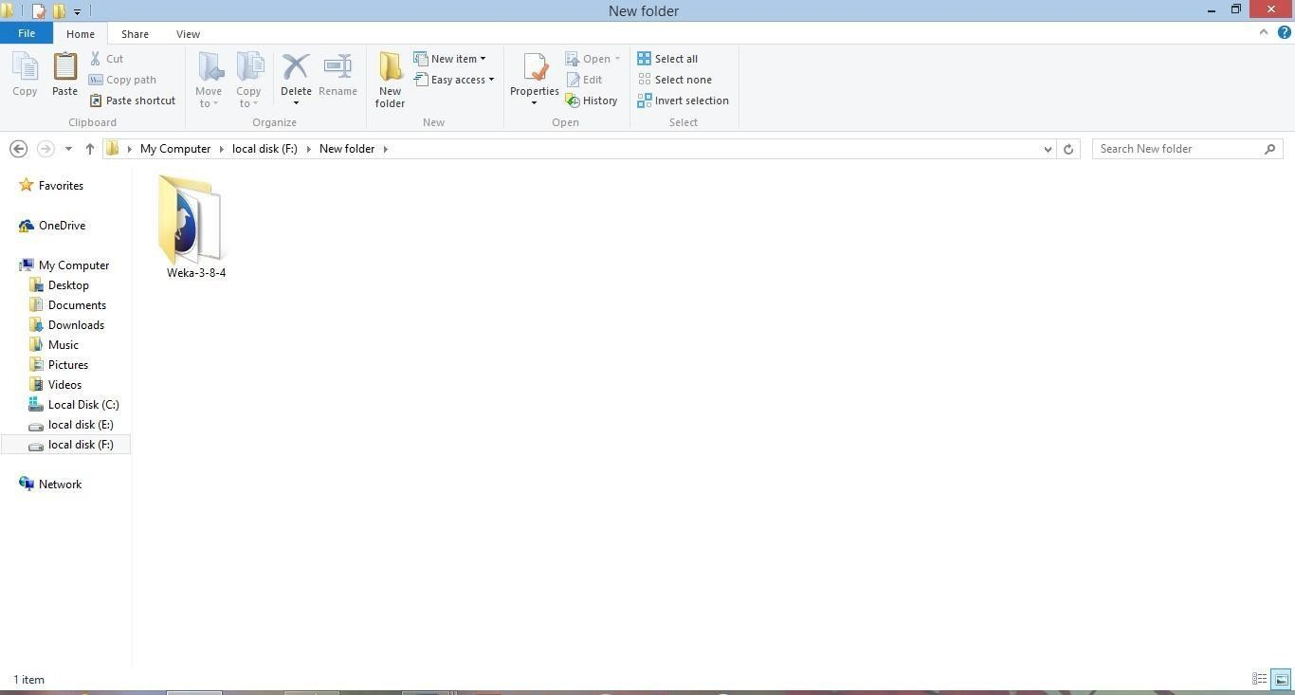

1. Click on the **weak 3.8.4** icon to start Weka.

The WEKA GUI Chooser application will start and you would see the following screen.

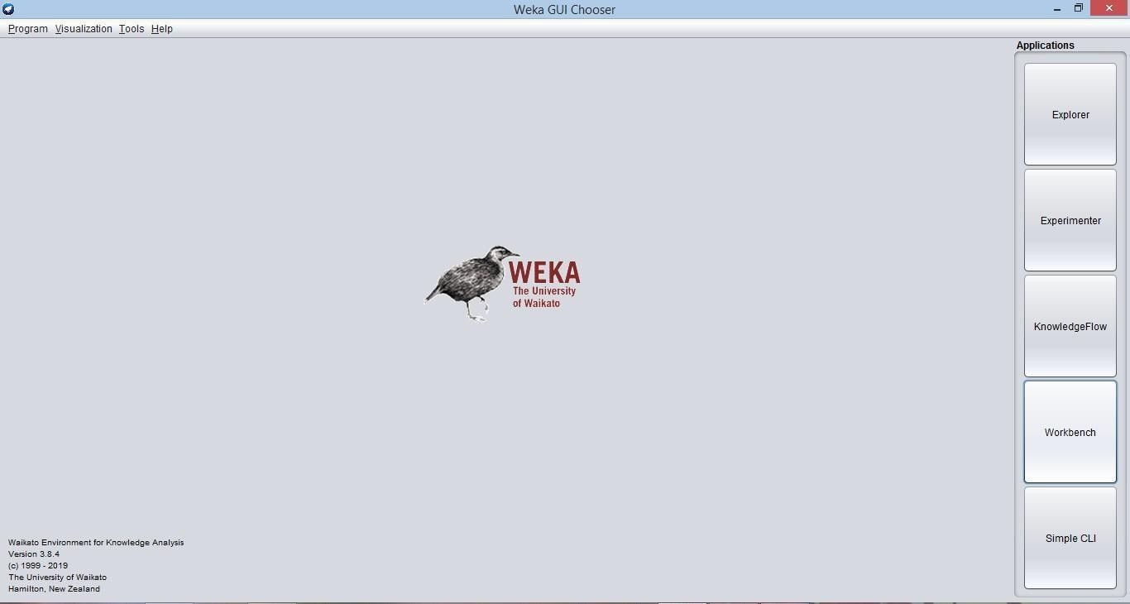

The GUI Chooser application allows you to run five different types of applications as listed above. Here I use **Workbench**.

1. When you click on the **Workbench** button in the **Applications** selector, it opens the following screen.

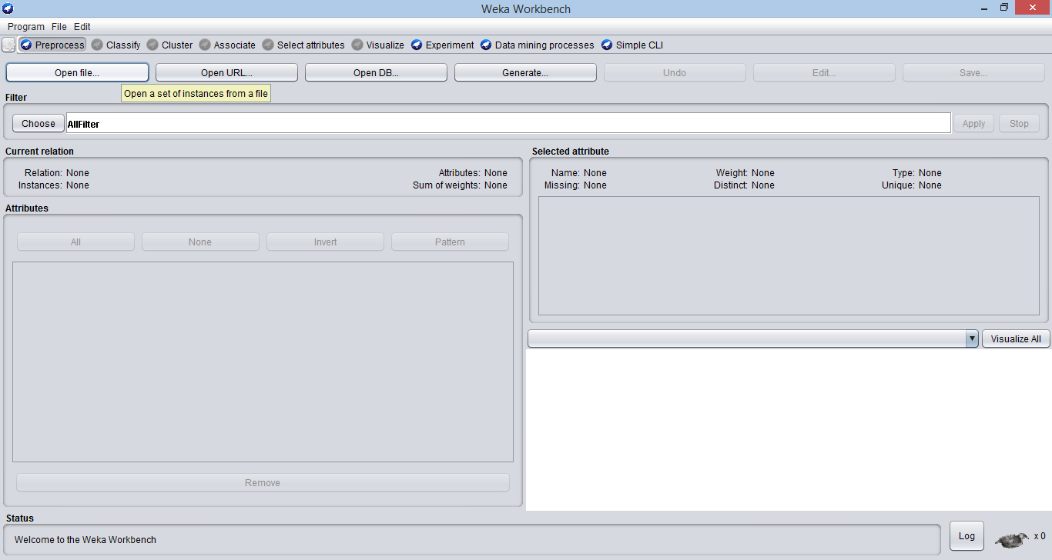

On the top, you will see several tabs as listed below.

* Preprocess: This allows us to choose the data file.
* Classify: This allows us to apply and experiment with different algorithms on preprocessed data files.
* Cluster: This allows us to apply different clustering tools, which identify clusters within the data file.
* Associate: This allows us to apply association rules, which identify the association within the data.
* Select Attributes: These allow us to see the changes on the inclusion and exclusion of attributes from the experiment.
* Visualize: This allows us to see the possible visualisation produced on the data set in a 2D format, in scatter plot and bar graph output.

Under these tabs, there are several pre-implemented machine learningalgorithms.

Data preprocessing is a must. There are three ways to inject the data for preprocessing:

* Open File: enables the user to select the file from the local machine
* Open URL: enables the user to select the data file from different locations
* Open Database: enables users to retrieve a data file from a database source

1. A screen for selecting a file from the local machine to be preprocessed is shown below. After loading the data in Workbench, we can refine the data by selecting different options. We can also select or remove the attributes as per our need and even apply filters on data to refine the result.

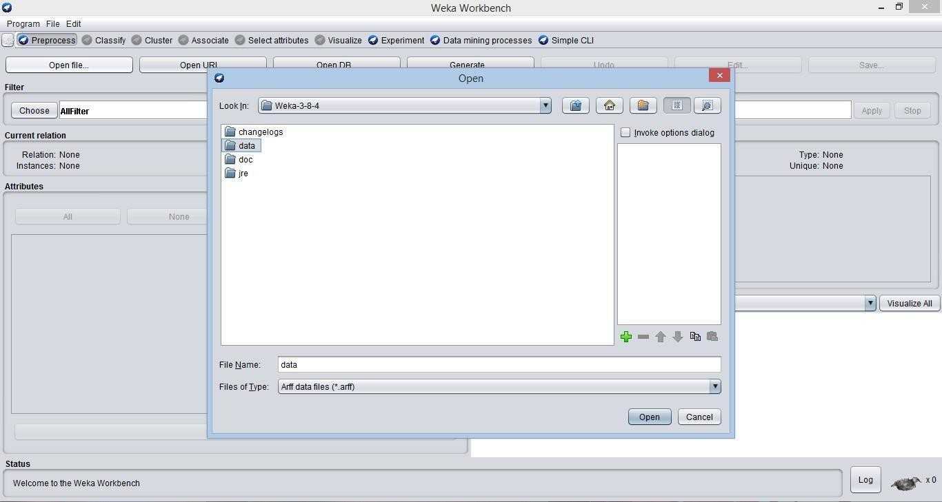

Now, navigate to the folder where your data files are stored. WEKA installation comes up with many sample databases for you to experiment. These are available in the **data** folder of the WEKA installation.

Open the weather dataset from the data folder as shown below.

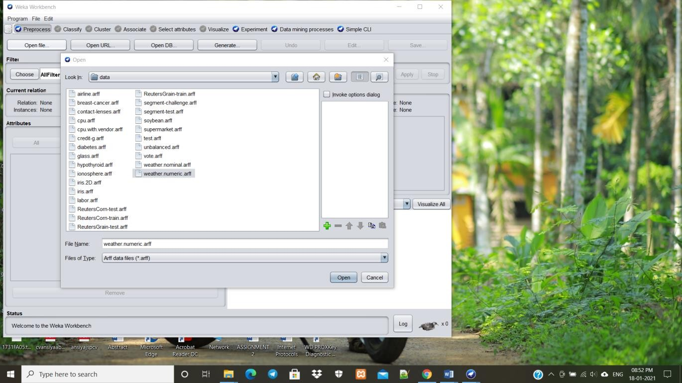

When you open the file, your screen looks like as shown below. This screen tells us several things about the loaded data.

Let us first look at the highlighted **Current relation** sub window. It shows the name of the database that is currently loaded. You can infer two points from this sub window −

* There are 14 instances - the number of rows in the table.
* The table contains 5 attributes - the fields.

On the left side, notice the **Attributes** sub window that displays the various fields in the database.

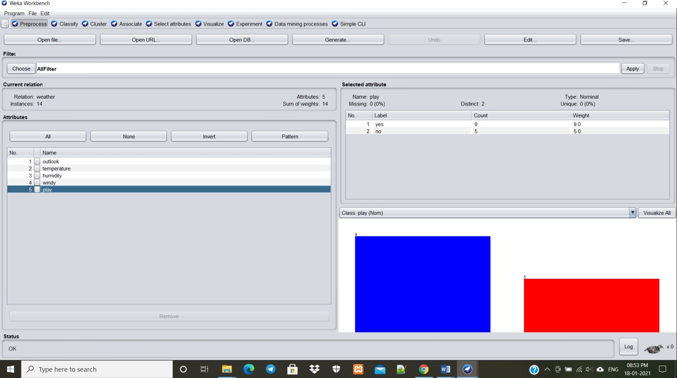

The **Weather** database contains five three fields. When you select an attribute from this list by clicking on it, further details on the attribute itself are displayed on the right hand side. Let us select the **humidity** attribute first. When you click on it, you would see the following screen.

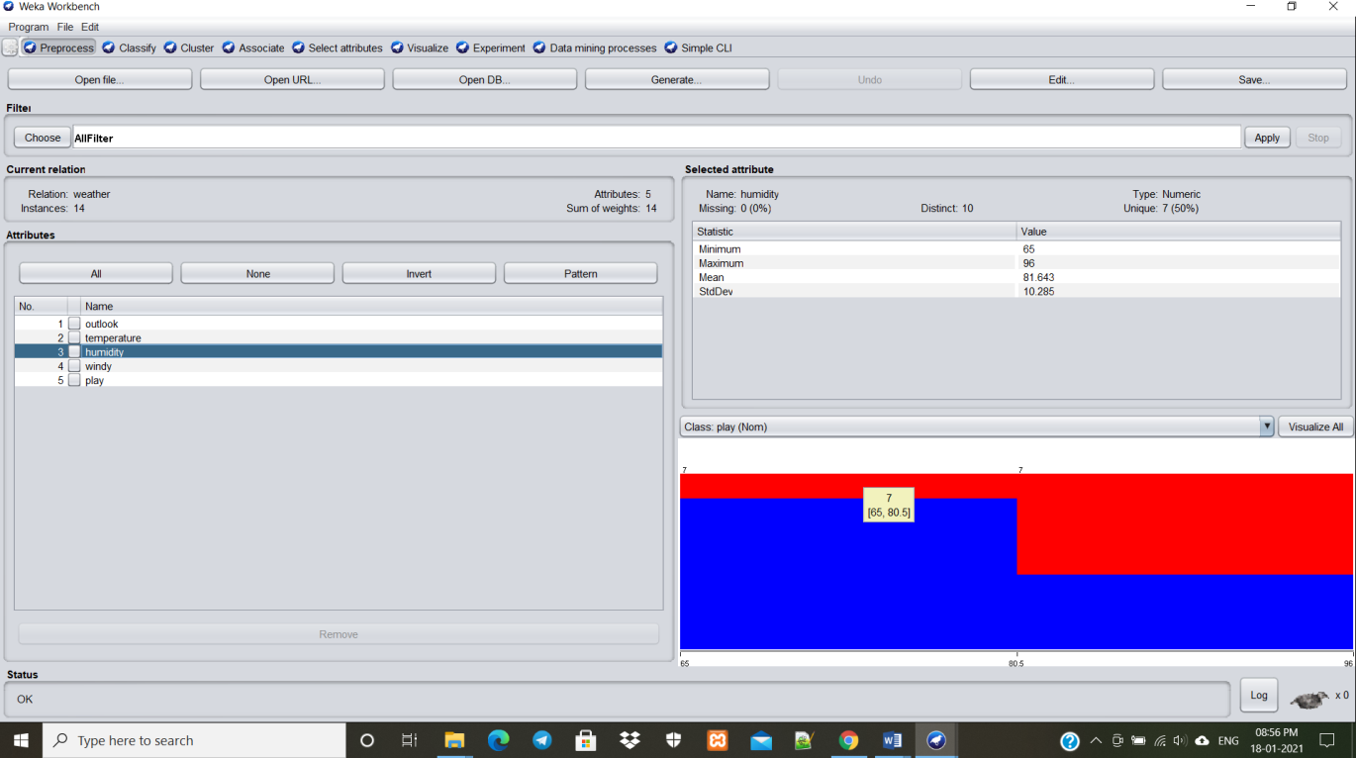

In the **Selected Attribute** subwindow, you can observe the following −

* The name and the type of the attribute are displayed.
* The type for the **humidity** attribute is **Numeric**.
* The number of **Missing** values is zero.
* There are ten **Distinct** values with no unique value.

1. At the bottom of the window, you see the visual representation of the **class** values by clicking on the **Visualize All** button, you will be able to see all features in one single window as shown below.

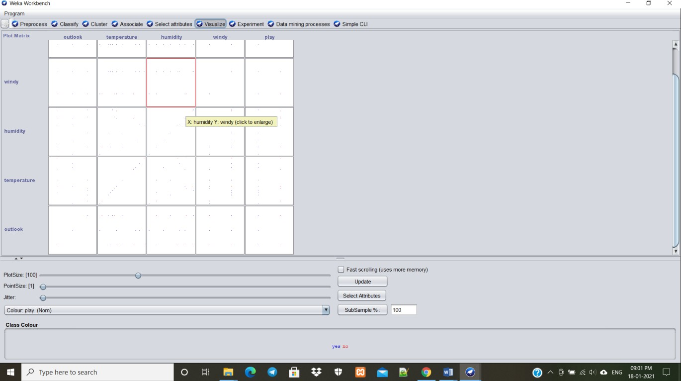

To predict nominal or numeric quantities, we have classifiers in Weka. Available learning schemes are decision-trees and lists, support vector machines, instance- based classifiers, logistic regression and Bayes’ nets. Once the data has been loaded, all the tabs are enabled. Based on the requirements and by trial and error, we can find out the most suitable algorithm to produce an easily understandable representation of data. To classify the data set based on the characteristics of attributes, Weka uses classifiers.

1. Click on the **Classify** tab and click on the Choose button, and you would see the following screen.

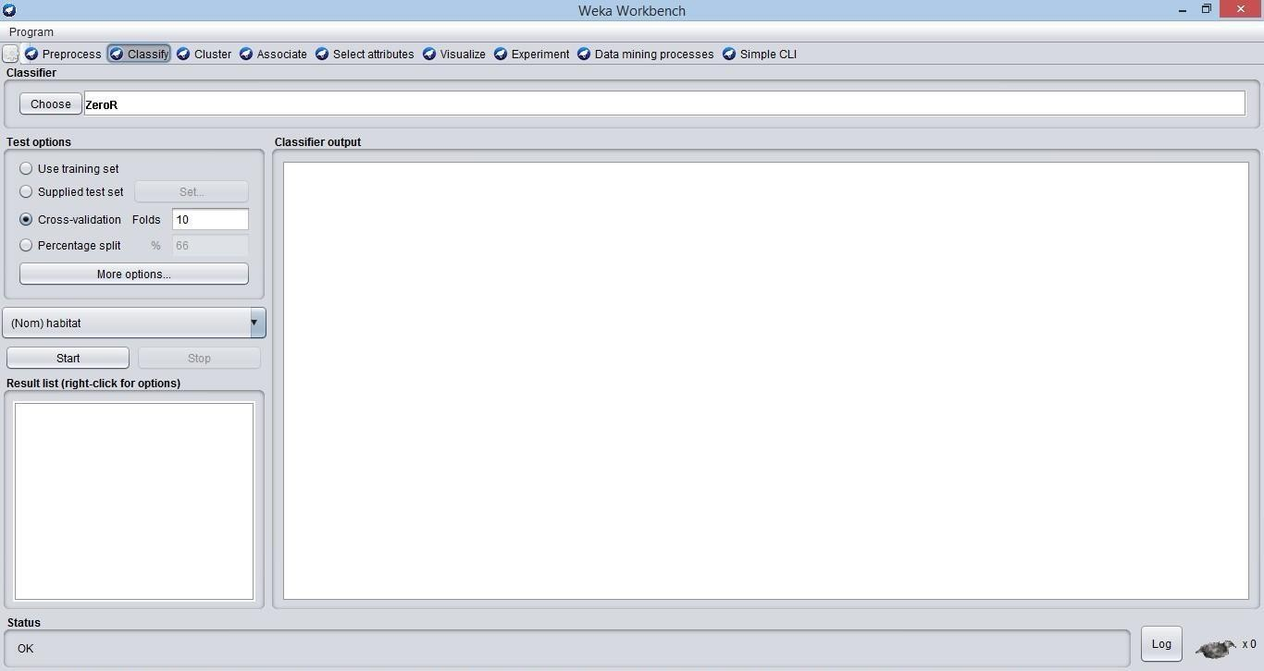

Unless you have your own training set or a client supplied test set, you would use cross-validation or percentage split options. Under cross- validation, you can set the number of folds in which entire data would be split and used during each iteration of training.

*Use training set:* Evaluation is based on how well it can predict the class of the instances it was trained on.

* *Supplied test set:* Evaluation is based on how well it can predict the class of a set of instances loaded from a file.
* *Cross-validation:* Evaluation is based on cross-validation by using the number of folds entered in the ‘Folds’ text field.
* *Split percentage:* Evaluation is based on how well it can predict a certain percentage of the data, held out for testing by using the values entered in the ‘%’ field.

1. Next, you will select the classifier. Click on the Choose button and select the following classifier.

# Weka > Classify > trees > J48

Here we choose J48 algorithm for training our dataset and generate decision tree. This is shown in the screenshot below.

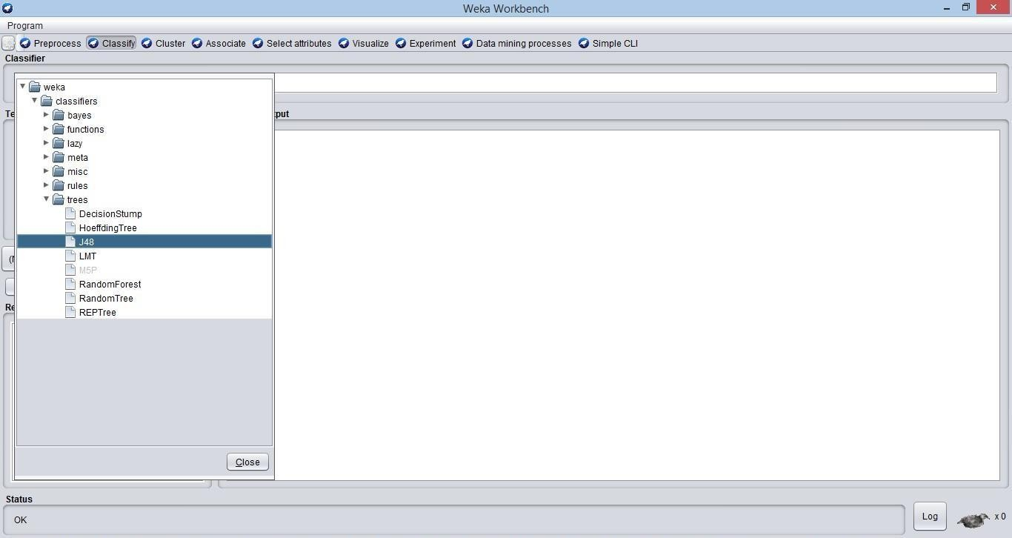

1. Click on the **Start** button to start the classification process. After a while, the classification results would be presented on your screen as shown below.

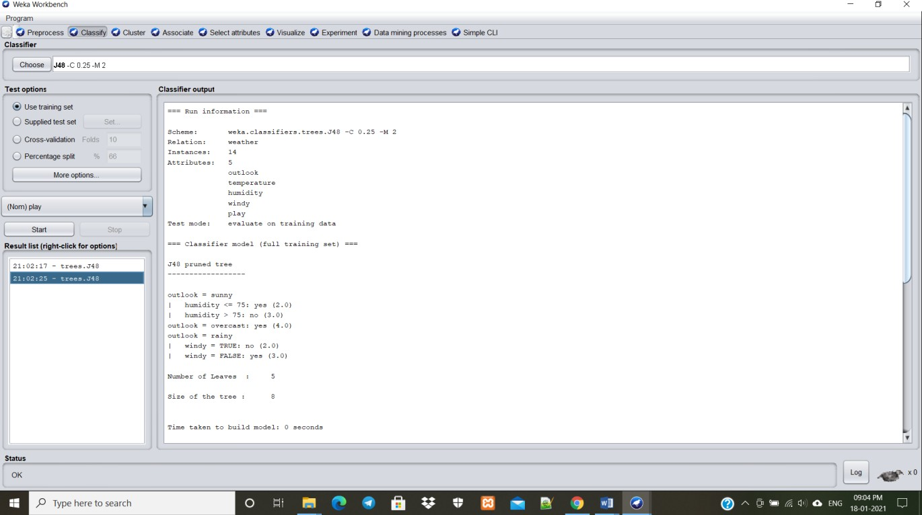

Let us examine the output shown on the right hand side of the screen. **Scheme:** The classification algorithm used. **Instances:** Number of data rows in the dataset. **Attributes:** The dataset has 5 attributes. Full classification of the J48 pruned with the attributes and number of instances.



The number of leaves and the size of the tree describes the decision tree. It says the size of the tree is 5 and number of leaves is 8. **Time taken to build the model:** Time for the output.

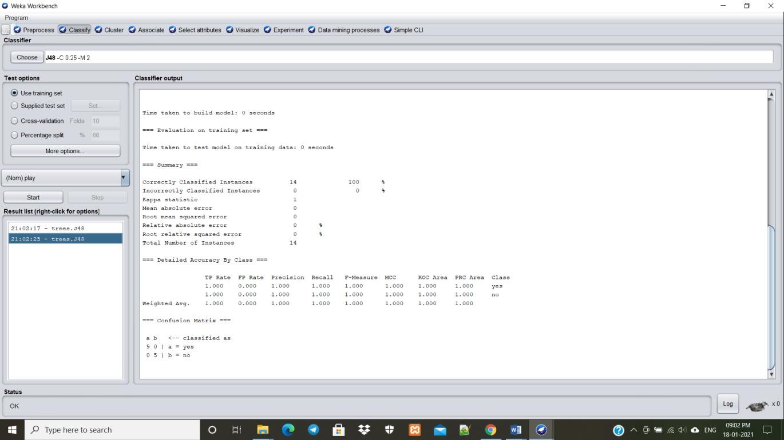

In the summary, it says that the accuracy is 100%, kappa statistics is 1,mean absolute error is 0. In the Confusion Matrix, it says that the correctly classified instances as 14.

1. To see the visual representation of the results, right click on the result in the

**Result list** box. Several options would pop up on the screen as shown below.

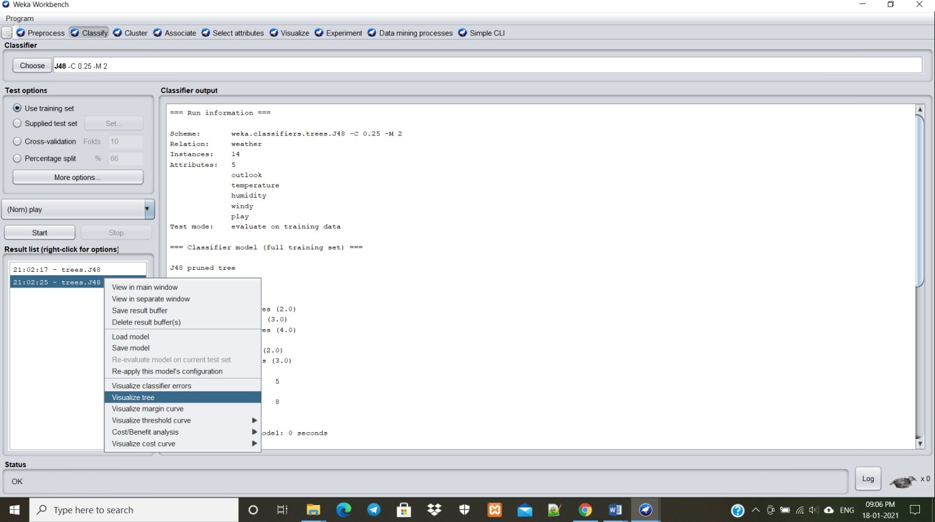

1. Select **Visualize tree** to get a visual representation of the traversal tree as seen in the screenshot below.

Here odor attribute is the root node, because it have the highest information gain. Information gain measures the amount of information contained in a set of data. It gives the idea of importance of an attribute in a dataset.

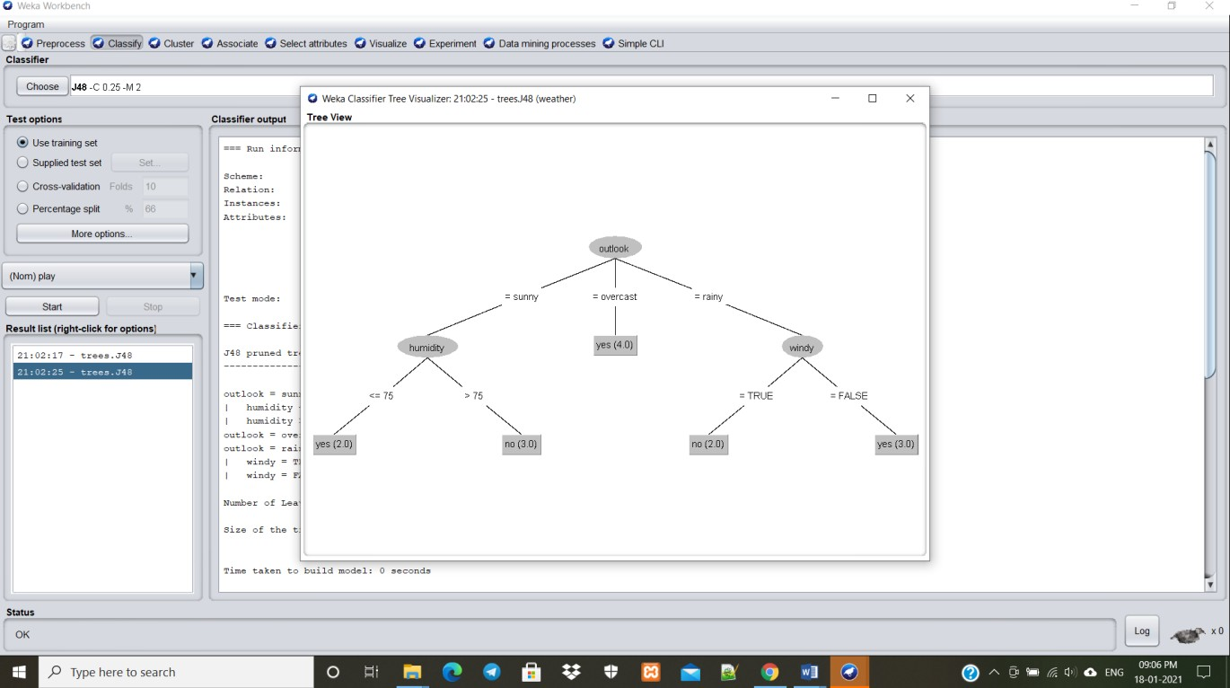

# NEW PROBLEM CONCEPT

1. **CONCLUSION**

This paper intends to study the classifier accuracy of various classification algorithms using WEKA tool on weather dataset. The experimental results of the various classification algorithms is listed. First the experiment was done on the weather dataset using j48 algorithm which classifies all the instances correctly. The accuracy of the j48 classifier is 100%.

The data is trained using J48 algorithm and a model is developed. Given a new set of attributes, the model is able to predict the category of mushroom. The target class of trained data set comes along with the attribute set, whereas the target class of test data is a fictitious one. If the fictitious target matches with the actual target, then the prediction margin is a positive value else negative. If the prediction margin is a positive value, it implies the prediction is correct.

WEKA offers a wide range of sample datasets to apply machine learning algorithms. The users can perform machine learning tasks such as classification, regression, attribute selection, association on these sample datasets, and can also learn the tool using them.

# REFERENCES

* + [https://www.researchgate.net/publication/321759431_A_Comparative_Analysis_of](https://www.researchgate.net/publication/321759431_A_Comparative_Analysis_of_Classification_Algorithms_on_Weather_Dataset_Using_Data_Mining_Tool_Article_History)

[_Classification_Algorithms_on_Weather_Dataset_Using_Data_Mining_Tool_Article_](https://www.researchgate.net/publication/321759431_A_Comparative_Analysis_of_Classification_Algorithms_on_Weather_Dataset_Using_Data_Mining_Tool_Article_History) [History](https://www.researchgate.net/publication/321759431_A_Comparative_Analysis_of_Classification_Algorithms_on_Weather_Dataset_Using_Data_Mining_Tool_Article_History)

* + <https://www.tutorialspoint.com/weka/weka_introduction.htm>
  + <https://www.opensourceforu.com/2017/01/an-introduction-to-weka/>
  + <https://www.youtube.com/watch?v=BxhPtYguXus>
  + <https://www.youtube.com/watch?v=TF1yh5PKaqI>